

MOI GIRLS’ ELDORET 2025 PREDICTION
POSSIBLE KCSE EXAM
PHYSICS
232/2
PAPER 2
THEORY
TIME: 2 HOURS

NAME……………………………………………………………………………………….
SCHOOL……………………………………………… SIGN………………………..
INDEX NO……………………………………………. ADM NO……………………

Kenya Certificate of Secondary Education (KCSE)

INSTRUCTIONS TO THE CANDIDATES:
• Write your name and index number in the spaces provided above
• This paper consists of two sections A and B.
• Answer all questions in section A and B in the spaces provided.
• All working must be clearly shown in the spaces provided.
• Mathematical tables and electronic calculators may be used.
• Take’g’ l0m/s 2

FOR EXAMINERS’ USE ONLY
SECTION | QUESTION | MAXIMUM SCORE | CANDIDATE’S SCORE
A | 1 - 14 | 25
B | 15 | 15
 | 16 | 14
 | 17 | 14
 | 18 | 12
TOTAL |  | 80

SECTION A
1 . What property of light is suggested by the formation of shadows? (1 mks)
…………………………………………………………………………………………………………
…………………………………………………………………………………………………………
2. You are provided with the following; A cell and holder, a switch, a rheostat, an Ammeter, a voltmeter and connecting wires. Draw a diagram for a circuit that could be used to investigate the variation of the potential difference across the cell with the current drawn from the cell. (2mks)

3. An un-magnetized steel rod is clamped facing North-South direction and then hammered repeatedly for some time. When tested, it is found to be magnetized. Explain this observation. (2mks)
…………………………………………………………………………………………………………
…………………………………………………………………………………………………………
…………………………………………………………………………………………………………

4. A lady holds a large concave mirror of focal length 1 m, 80 cm from her face, state two characteristics of her image in the mirror. (2 mks)
…………………………………………………………………………………………………………
…………………………………………………………………………………………………………

5. A girl brought a positively charged rod close to the cap of a gold leaf electroscope; she observed that the gold leaf diverged further. Explain this observation. (2mks)
…………………………………………………………………………………………………………
…………………………………………………………………………………………………………
…………………………………………………………………………………………………………
…………………………………………………………………………………………………………

6. In an experiment using a ripple tank the frequency, f, of the electric pulse generator was reduced to one third of its value. How does the new wavelength compare with the initial wavelength? (3 marks
…………………………………………………………………………………………………………
…………………………………………………………………………………………………………
…………………………………………………………………………………………………………
…………………………………………………………………………………………………………
…………………………………………………………………………………………………………
…………………………………………………………………………………………………………

7. Figure 1 shows a ray of light incident on the face of a water prism

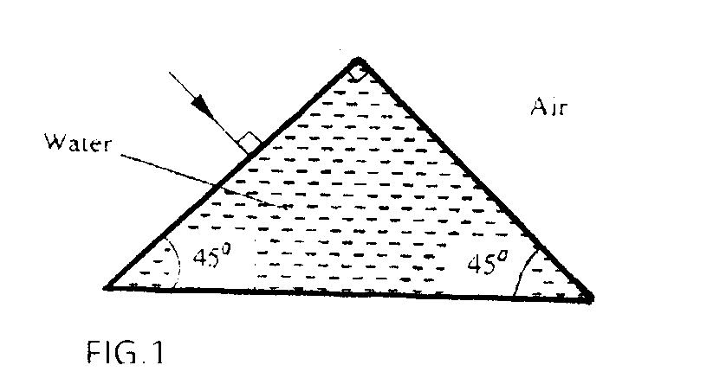

Sketch the path of the ray as it passes though the prism. Critical angle for water is 49⁰ (1mk)

8. A heating coil is rated 100W, 240V. At what rate would it dissipate energy if it is connected to a 220V supply? (3mk)
…………………………………………………………………………………………………………
…………………………………………………………………………………………………………
…………………………………………………………………………………………………………
…………………………………………………………………………………………………………
…………………………………………………………………………………………………………

9. Figure 2 shows an object 0 placed in front of a concave lens with principal foci F and F Construct a ray diagram to locate the position of the image (1mk)

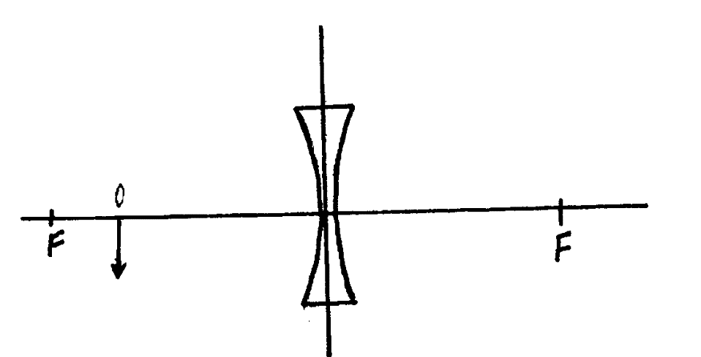

10. State the difference between X-rays and Gamma rays in the way in which they are produced.
(1mk)
…………………………………………………………………………………………………………
…………………………………………………………………………………………………………
…………………………………………………………………………………………………………

11. A 60W bulb is used continuously for 36 hours. Determine the energy consumed. Give your
answer in kilowatt hour (kwh). (2mks)
…………………………………………………………………………………………………………
…………………………………………………………………………………………………………
…………………………………………………………………………………………………………
…………………………………………………………………………………………………………
…………………………………………………………………………………………………………
…………………………………………………………………………………………………………

12 A narrow beam of electrons in a cathode ray oscilloscope (CR0) strike the screen producing a spot. State what is observed on the screen if a low frequency a.c source is connected across the y- input of the CRO (1mk)
…………………………………………………………………………………………………………
…………………………………………………………………………………………………………

In an experiment on photo- electricity using metal X, the graph shown in figure 3 was obtained Use the graph to answer questions 13.

13. Determine the minimum frequency Fo below which no photoelectric emission occurs.(1mk)
…………………………………………………………………………………………………………
…………………………………………………………………………………………………………
…………………………………………………………………………………………………………
…………………………………………………………………………………………………………

14 .You are provided with 12V a. c source, four diodes and resistor. Draw a circuit diagram for a full wave rectifier and show the points at which the output is taken. (2mk)

15. (a) Given a bar magnet, an iron bar and a string
(i) Describe a simple experiment to distinguish between the magnet and the iron bar
…………………………………………………………………………………………………………
…………………………………………………………………………………………………………
…………………………………………………………………………………………………………
(ii) State with reasons the observation that would be made in the experiment. (2mks)
…………………………………………………………………………………………………………
…………………………………………………………………………………………………………
…………………………………………………………………………………………………………
…………………………………………………………………………………………………………

(b) In an experiment to magnetize two substances P and Q using electric current, two curves (graphs) were obtained as shown in figure 4
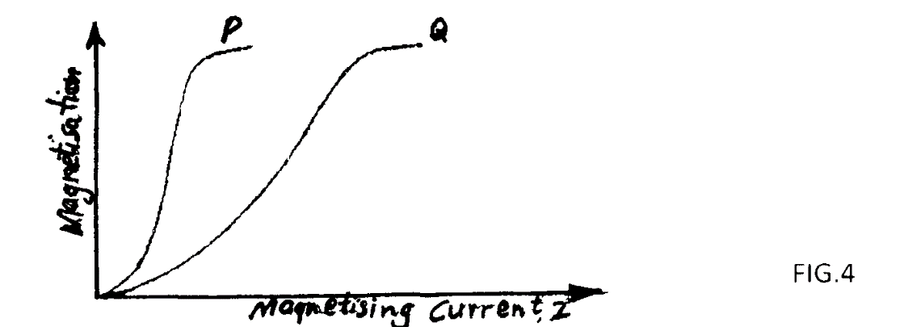
Using the information in fig. 4 explain the differences between substances P and Q with references to the domain theory (6mks)
…………………………………………………………………………………………………………
…………………………………………………………………………………………………………
…………………………………………………………………………………………………………
…………………………………………………………………………………………………………
…………………………………………………………………………………………………………
…………………………………………………………………………………………………………
…………………………………………………………………………………………………………
…………………………………………………………………………………………………………
…………………………………………………………………………………………………………

(c) In the set up in figure 5, the suspended metre rule is in equilibrium balanced by the magnet and the weight shown. The iron core is fixed to the bench.
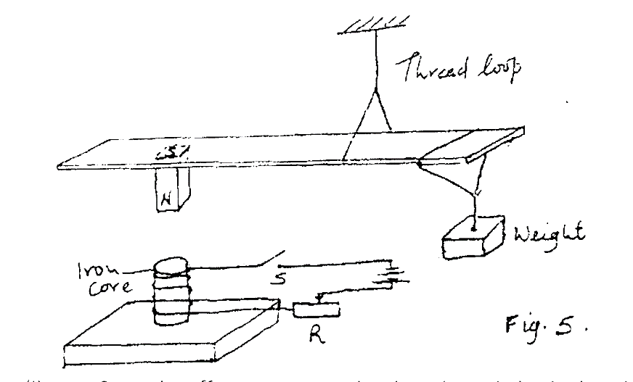
(i) State the effect on metre rule when the switch S is closed. (1mk)
…………………………………………………………………………………………………………
…………………………………………………………………………………………………………

(ii) What would be the effect of reversing the battery terminals? (1mk)
…………………………………………………………………………………………………………
…………………………………………………………………………………………………………

(iii) Suggest how the set up in figure 5 can be adapted to measure the current flowing in
the current circuit. (3mk)
…………………………………………………………………………………………………………
…………………………………………………………………………………………………………
…………………………………………………………………………………………………………
…………………………………………………………………………………………………………

16. (a) (i) What is the difference between longitudinal and transverse waves? (1mk)
…………………………………………………………………………………………………………
…………………………………………………………………………………………………………
…………………………………………………………………………………………………………

(ii) State two distinctions between the way sound waves and electromagnetic waves are transmitted (2mk)
…………………………………………………………………………………………………………
…………………………………………………………………………………………………………
…………………………………………………………………………………………………………

(b) A mineworker stands between two vertical cliffs 400m from the nearest cliff. The cliffs are X distance apart. Every time he strikes the rock once, he hears two echoes, the first one after 2.55 , while the second follows 2s later. From this information; calculation:
(i) The speed of the sound in air (2mk)
…………………………………………………………………………………………………………
…………………………………………………………………………………………………………
…………………………………………………………………………………………………………
…………………………………………………………………………………………………………

(ii) The value of X (3mk)
…………………………………………………………………………………………………………
…………………………………………………………………………………………………………
…………………………………………………………………………………………………………
…………………………………………………………………………………………………………
…………………………………………………………………………………………………………

(c) In an experiment to observe interference of light waves a double slit is placed close to the source. See figure 5


(i) State the function of the double slit (1mk)
…………………………………………………………………………………………………………
…………………………………………………………………………………………………………

(ii) Describe what is observed on the screen (2 mks)
…………………………………………………………………………………………………………
…………………………………………………………………………………………………………
…………………………………………………………………………………………………………
…………………………………………………………………………………………………………

(iii) State what is observed on the screen when
i). The slit separation S1S2 is reduced (1mk)
…………………………………………………………………………………………………………
…………………………………………………………………………………………………………

ii) White light source is used in place of monochromatic source (1mk)
…………………………………………………………………………………………………………
…………………………………………………………………………………………………………

17.a)The diagram in figure 6 below shows a narrow beam of white light onto a glass Prism.
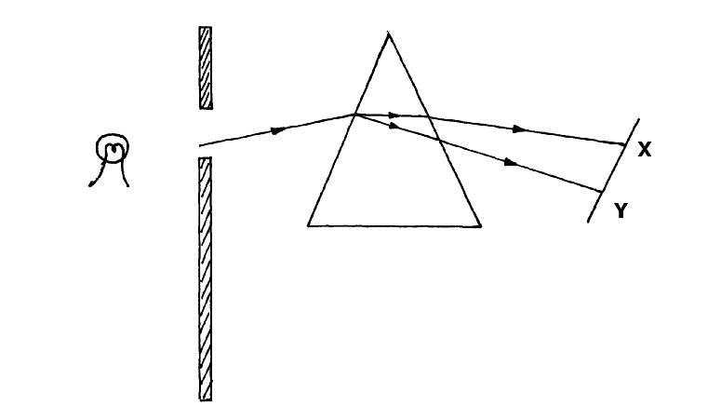

(i) What is the name of the phenomenon represented in the diagram? (1mks)
…………………………………………………………………………………………………………

(ii) Name the colour at x and Y. (2mk)
…………………………………………………………………………………………………………
…………………………………………………………………………………………………………

(iii) Give a reason for your answer in part (ii) above. (1mk)
…………………………………………………………………………………………………………
…………………………………………………………………………………………………………

(iv) What is the purpose of the slit? (1mk)
…………………………………………………………………………………………………………
…………………………………………………………………………………………………………

b) Figure 7 below shows the path of ray of yellow light through a glass prism. The speed of yellow light in the prism is 1.8 x 10⁸ m/s.
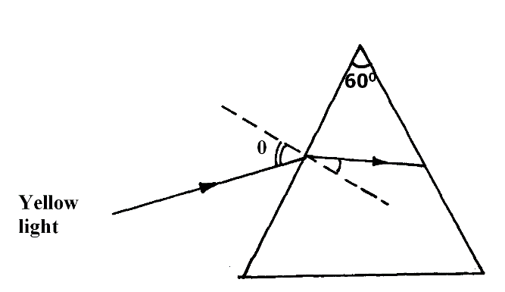
i) Determine the refractive index of the prism material ( Speed of light in vacuum, C = 3.0 x 10⁸ m/s) (3mks)
…………………………………………………………………………………………………………
…………………………………………………………………………………………………………
…………………………………………………………………………………………………………
…………………………………………………………………………………………………………
…………………………………………………………………………………………………………

(ii) Show on the same diagram, the critical angle c and hence determine its value. (3mks)

(iii) Given that r = 31.2⁰, determine the angle 0. (3mks)
…………………………………………………………………………………………………………
…………………………………………………………………………………………………………
…………………………………………………………………………………………………………
…………………………………………………………………………………………………………
…………………………………………………………………………………………………………

18. (a ) X- rays are used for detecting cracks inside meta’ beams (i)State the type of the X- rays used.
…………………………………………………………………………………………………………
…………………………………………………………………………………………………………
…………………………………………………………………………………………………………
…………………………………………………………………………………………………………

(ii) Give a reason for your answer in (i) above.
…………………………………………………………………………………………………………
…………………………………………………………………………………………………………
…………………………………………………………………………………………………………
…………………………………………………………………………………………………………

(b) Figure 1 shows the features of an X- ray tube
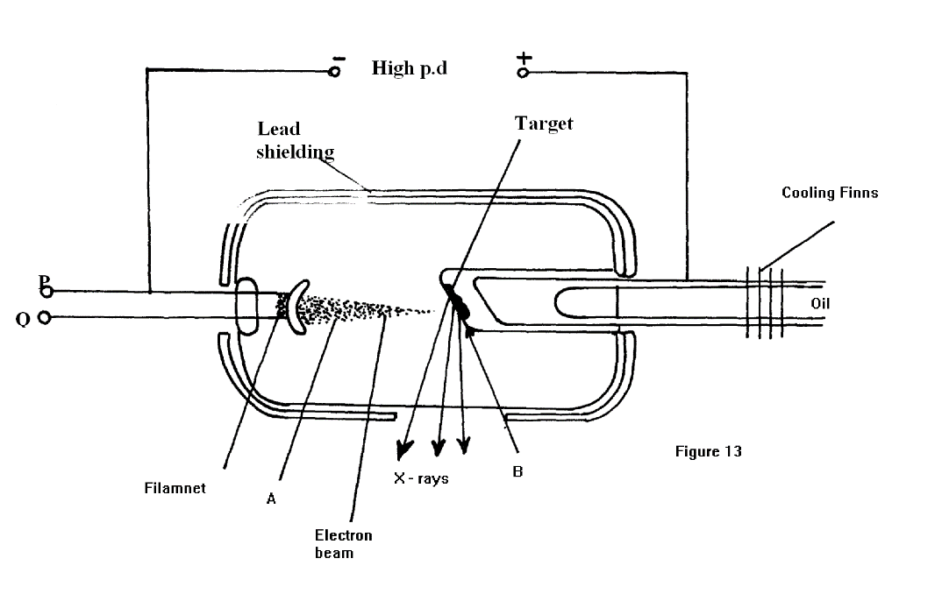

i) Name the parts labelled A and B. (2mks)
…………………………………………………………………………………………………………
…………………………………………………………………………………………………………

(ii) Explain how a change in the potential across P changes the intensity of the X- rays produced in the tube. (2 mks)
…………………………………………………………………………………………………………
…………………………………………………………………………………………………………
…………………………………………………………………………………………………………
…………………………………………………………………………………………………………

(iii)During the operation of the tube, the target becomes very hot. Explain how this heat is caused. (2 mks)
…………………………………………………………………………………………………………
…………………………………………………………………………………………………………
…………………………………………………………………………………………………………
…………………………………………………………………………………………………………

(iv)What property of lead makes it suitable for use as shielding material? (1mk)
…………………………………………………………………………………………………………
…………………………………………………………………………………………………………

(c)ln a certain X- ray tube, the electrons are accelerated by a Pd of 12000V. Assuming all the energy goes to produce X- rays, determine the frequency of the X- rays produced. (Plank’s constant h= 6.62 x 10⁻³⁴ is and charge on an electron, e = 1.6 x 10 ⁻¹⁹C). (3mks)
…………………………………………………………………………………………………………
…………………………………………………………………………………………………………
…………………………………………………………………………………………………………
…………………………………………………………………………………………………………
…………………………………………………………………………………………………………
…………………………………………………………………………………………………………
…………………………………………………………………………………………………………
…………………………………………………………………………………………………………

